
Company
Logotype

Cone Beam Computed Tomography- Report



Porur Dental X-rays & CBCT

Patient Name : Mrs. Jagadeshwari | Date of Report : 12.05.2024
Age/ Gender : 70 years/ Female | Region of Interest : CBCT Full Skull
Referring doctor: Dr. A. Dany | Indication : Implant assessment
Clinical Notes: Nil
PATIENT INFORMATION

CBCT- Full Skull provided
CBCT – IMAGE DETAILS

RADIOGRAPHIC INTERPRETATION

- Teeth present in the maxillary and mandibular arch are: 27, 31, 32, 38, 43, 44, 48.
- Root stumps: 41.
- The alveolar ridge in relation to the maxillary and mandibular alveolar ridge are present with normal trabecular pattern.
- Hyperdense crown structure is evident in relation to 31, 32, 41, 42, 43, 44, 45, 46.

IMPLANT ASSESSMENT

 | 11 region | 12 region | 13 region | 14 region | 21 region | 22 region | 23 region | 24 region
Sub-Crestal | 3 | 2.5 | 2 | 4.4 | 2.4 | 2.5 | 4.5 | 4.7
Mid- Crestal | 3.7 | 3.3 | 2.9 | 4.7 | 3.4 | 3.7 | 4.6 | 4.8
Distance between the alveolar ridge and Floor of the Nasal cavity (in mm) | 13.9 | 12.4 | 13.9 | 13.8 | 12.7 | 13.2 | 14.7 | 16.5

 | 15 region | 16 region | 17 region | 25 region | 26 region | 27 region
Sub-Crestal (in mm) | 4.5 | - | - | 5 | 8 | 10.5
Mid- Crestal (in mm) | 5.3 | - | - | 5.8 | 9.8 | 12.3
Distance between the alveolar ridge and floor of the maxillary sinus (in mm) | 10.1 | 1.6 | 2 | 10.1 | 7.2 | 6.9

 | 31 region | 32 region | 33 region | 34 region
Sub-Crestal (in mm) | 5.4 | 6.2 | 4.2 | 6.5
Mid- Crestal (in mm) | 5.8 | 6.3 | 6 | 7.7
Distance between alveolar ridge and the inferior border of mandible (in mm) | 23.4 | 22.6 | 23.9 | 24.7

 | 41 region | 42 region | 43 region | 44 region
Sub-Crestal (in mm) | 4.1 | 3.5 | 7.1 | 6
Mid- Crestal (in mm) | 4.2 | 4.3 | 6.8 | 6.8
Distance between alveolar ridge and the inferior border of mandible (in mm) | 22.1 | 21.8 | 23.9 | 23.8
 | 45 region | 46 region | 47 region
Sub-Crestal (in mm) | 5.4 | 5.2 | 4.9
Mid- Crestal (in mm) | 6.8 | 6.8 | 7.2
Distance between alveolar ridge and the inferior alveolar nerve canal (in mm) | 11.9 | 12.7 | 13.6
Distance between alveolar ridge and the inferior border of mandible (in mm) | 24.4 | 22.8 | 24.4

 | 35 region | 36 region | 37 region
Sub-Crestal (in mm) | 6.2 | 4.4 | 5.4
Mid- Crestal (in mm) | 6.3 | 6 | 7.4
Distance between alveolar ridge and the inferior alveolar nerve canal (in mm) | 15.3 | 15.1 | 12.8
Distance between alveolar ridge and the inferior border of mandible (in mm) | 24.5 | 24.7 | 24.4

RADIOGRAPHIC IMPRESSION

- Partially edentulous maxillary and mandibular arch.
- Root stumps: 41.

Kindly correlate with clinical findings


IMAGES FOR REFERENCE

RECONSTRUCTED PANORAMIC VIEW

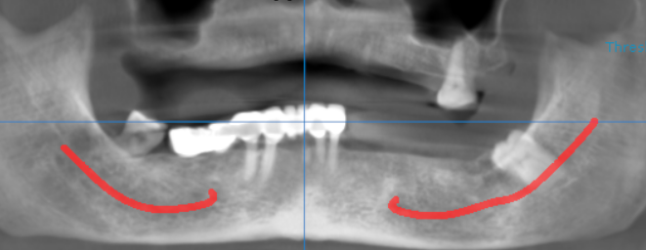

3-DIMENSIONAL VIEW

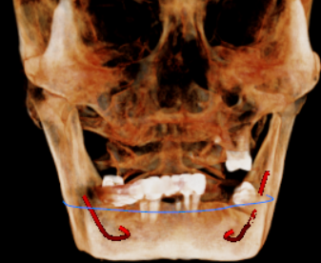

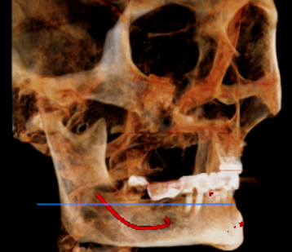
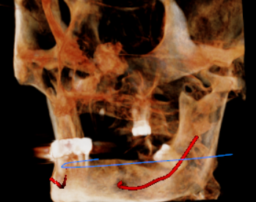

CROSS SECTIONAL VIEW

11 region | 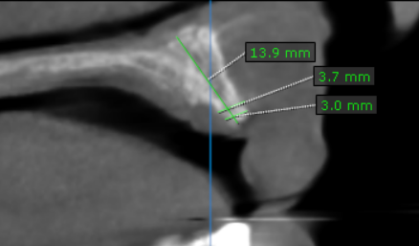
12 region | 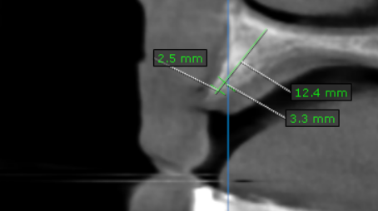
13 region | 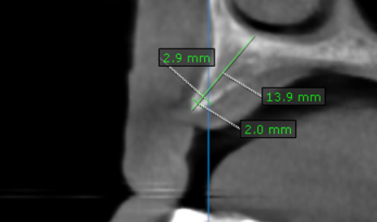
14 region | 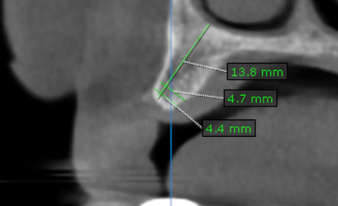
15 region | 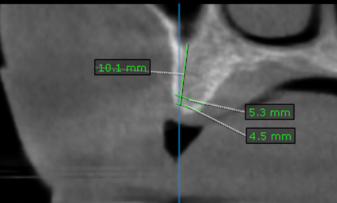
16 region | 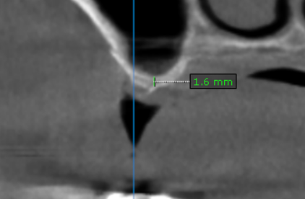
17 region | 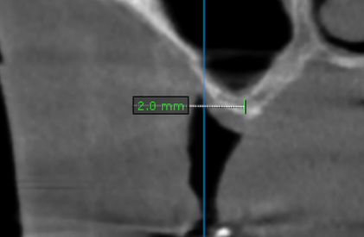
21 region | 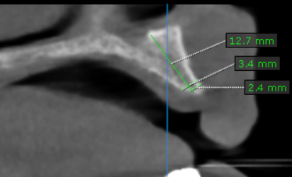
22 region | 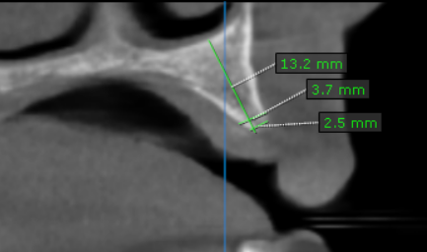
23 region | 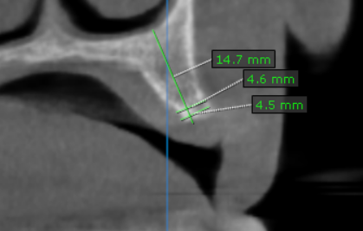
24 region | 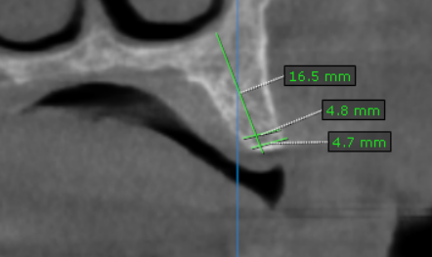
25 region | 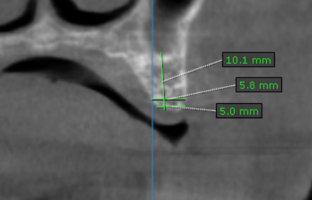
26 region | 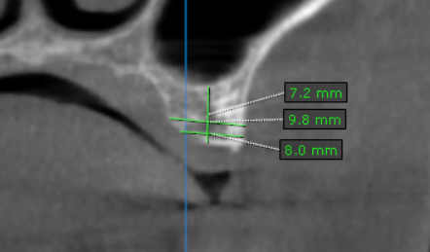
27 region | 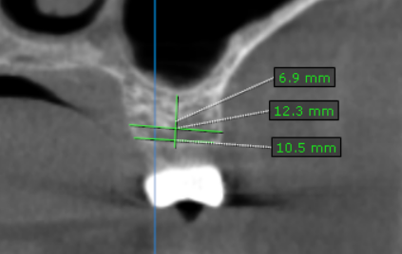
31 region | 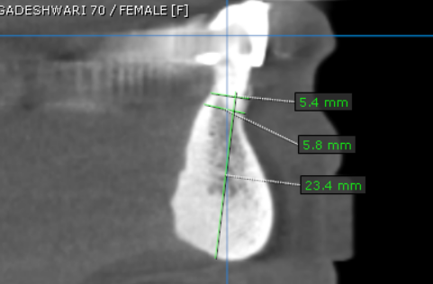
32 region | 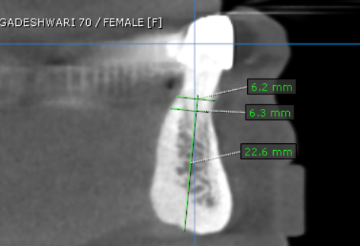
33 region | 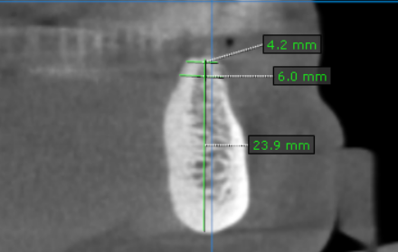
34 region | 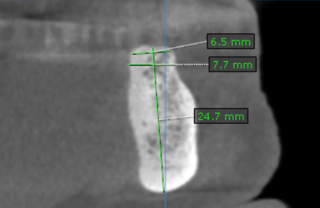
35 region | 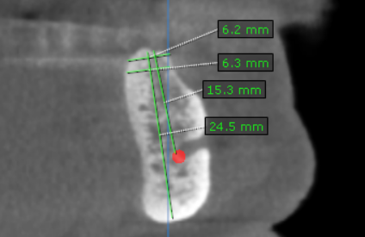
36 region | 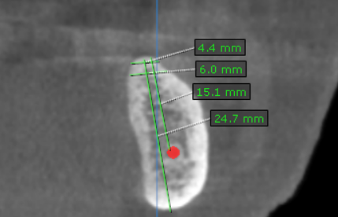
37 region | 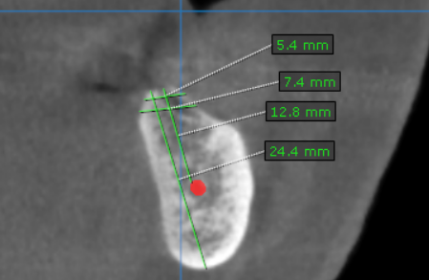
41 region | 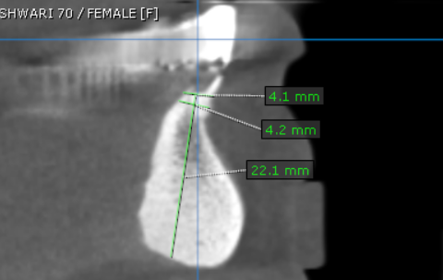
42 region | 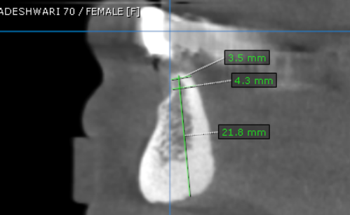
43 region | 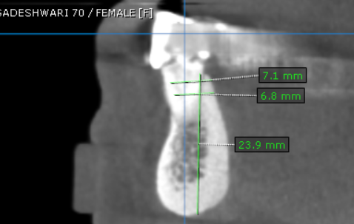
44 region | 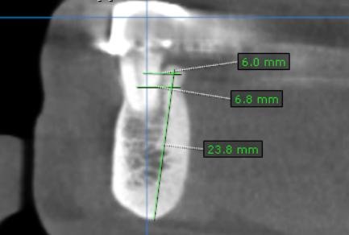
45 region | 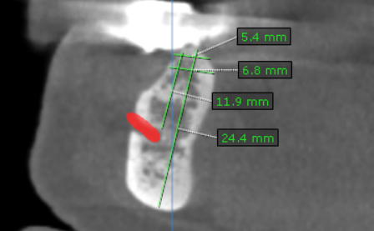
46 region | 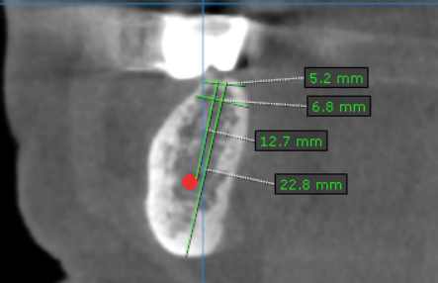
47 region | 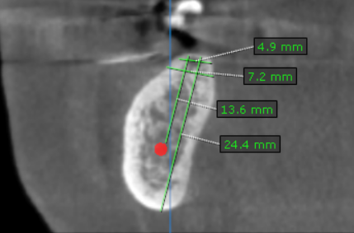

**** End of report ****

